# Cloud server

היום אנחנו משתמשים ב- thingSpeak. זה פלטפורמת ענן שמדברת עם ה- clients ב- http. הם מספקים libraries של קוד לשימוש ב- client-ים נפוצים.

* העלאת מידע ואחסונו בענן
* כלי ניתוח בסיסיים
* יכולת תגובה לתנאים מוגדרים מראש

המידע ב- thingSpeak מאוחסן ב- channel-ים. כאשר client מעלה data, הוא אומר לאיזה מה- channels הוא רוצה לשמור. בדרך כלל נחזיק channel לכל endpoint.

# End point unit

## Endpoint battery

* עלות
* עמידה בתנאי סביבה
* Capacity
* מחיר
* זמינות

עלות: 15 שקלים

## Endpoint unit microcontroller

|  |  |  |
| --- | --- | --- |
| Chip | Esp32 model WRoom-32 | Espressif |
| Development board | Ttgo  Or  Lolin32  Both use WRoom-32 | Wemos |

יתרונות של המיקרו-קונטרולרים האלו:

* זולים
* ביצועים טובים
* Bluetooth, Wifi
* פרוטוקול תקשורת proprietary בשם ESPNow

עלות: 66 שקלים

## Endpoint Humidity sensor

Capacitive humidity sensor. תוצרת DFRobot. עלות: 10 שקלים.

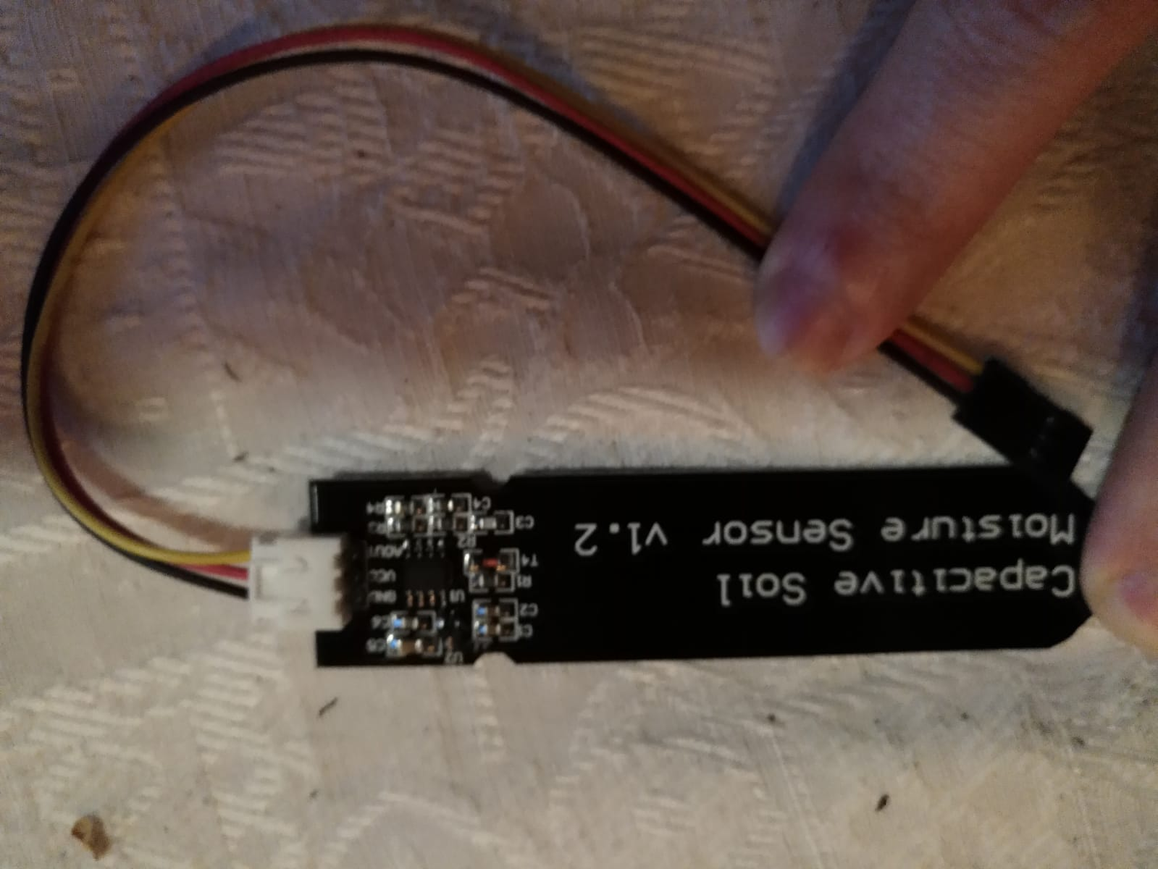

## Endpoint wiring

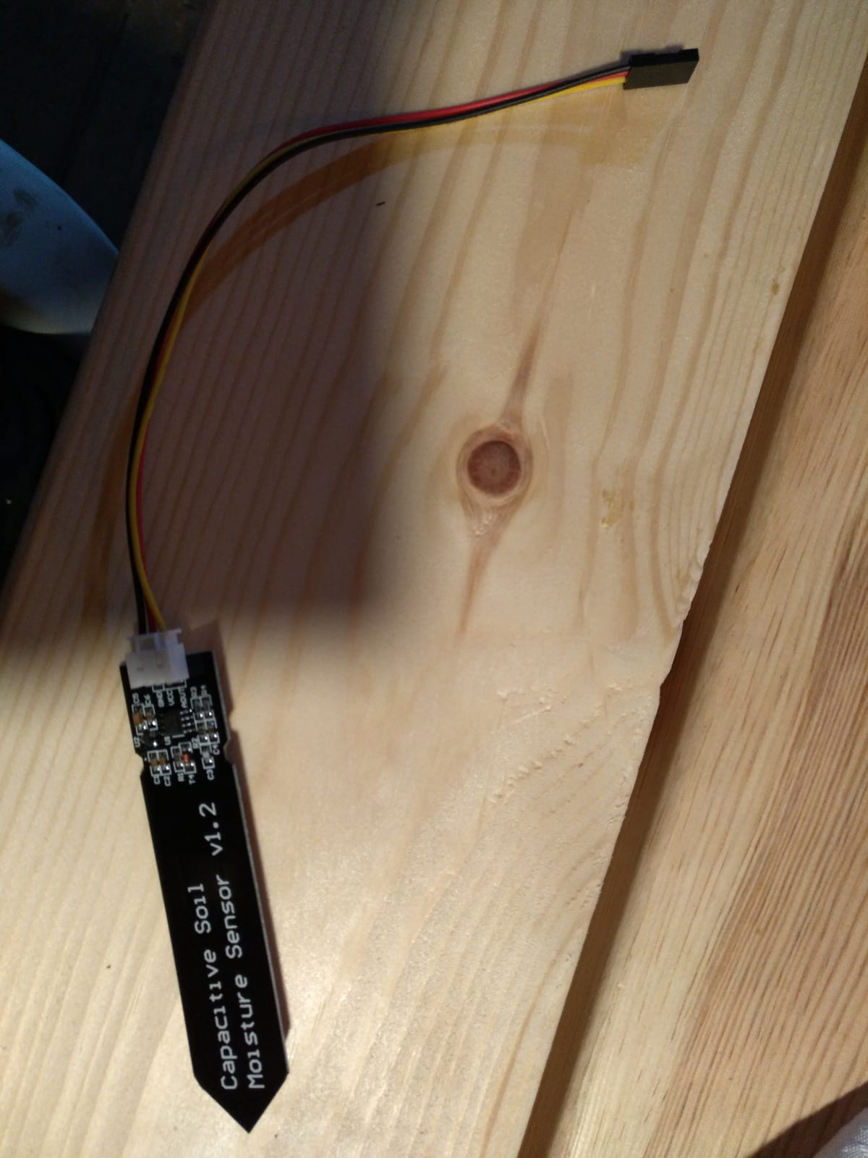

The blue areas indicate potting points, for waterproofing.

Potting of sensor:

We use a nylon bag filled with silicon.

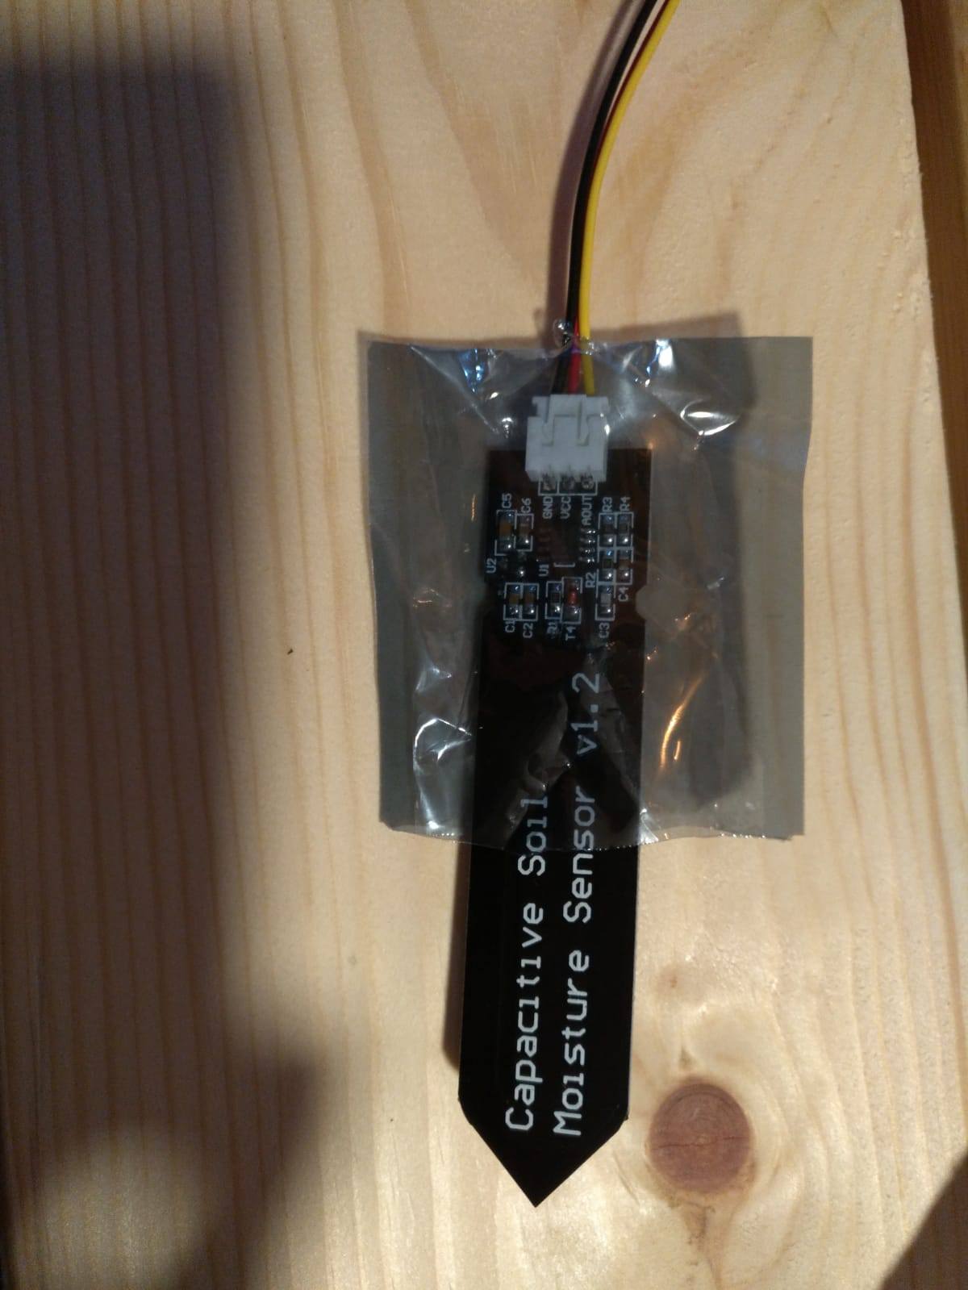

# Network topology

* The tap controller connects to the router through wifi as a client
* Opens an access point service to serve the endpoints
* Delivers messages from the endpoints to the cloud server

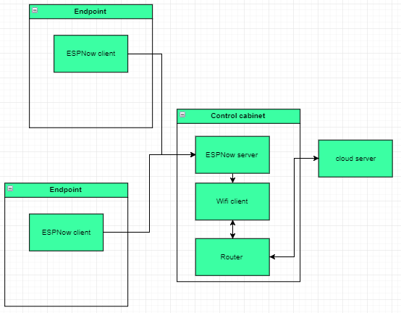

# Versions

## Endpoint version 0.0.1

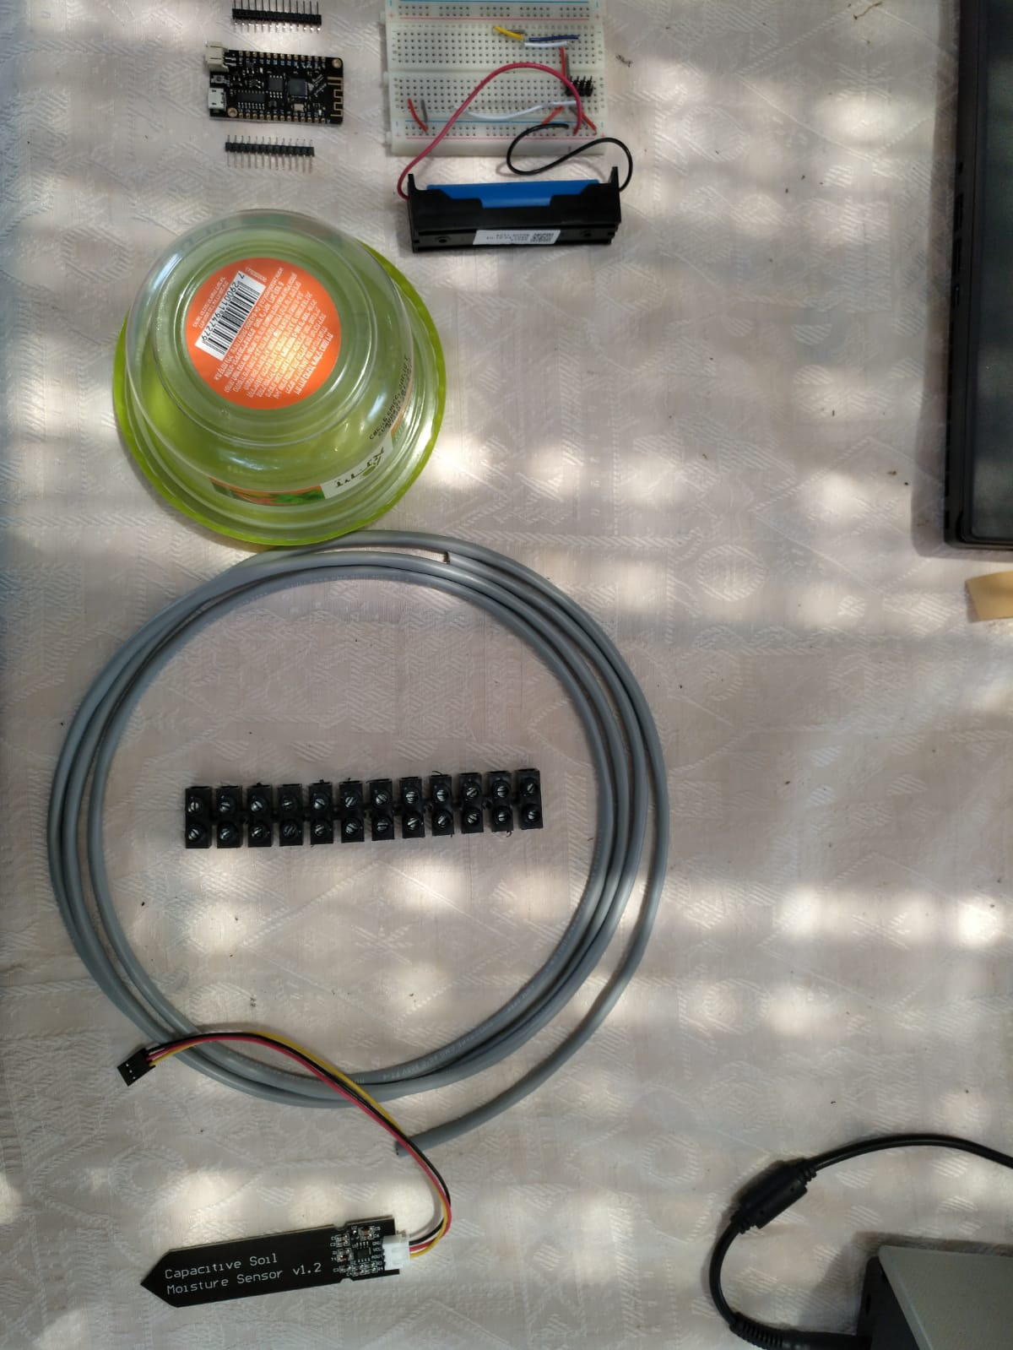

1. Cut the moisture sensor’s cables. Leave about 4 cm. Then connect them to the extension cord.
2. Insulate the sensor and the connection to the extension cord together using silicone
3. The design is to connect the extension cable to the breadboard using screw terminals, but since we currently don’t have them, we will use the end of the sensor cable that we cut, as it has a connector to a breadboard header.
4. Solder the battery holder cables to the Lolin’s JST battery connector. (Red and black cables)
5. Solder the Lolin’s headers to the Lolin board
6. Connect the soldered Lolin to the breadboard
7. Using jumpers, connect the Lolin to the sensor header using 3 pins:
   1. Ground.
   2. 3.3 Vcc. Pin 17
   3. Analog signal. Pin 33
8. Place the battery in the battery holder
9. Place the battery holder and the breadboard in the plastic box

# Passwords

|  |  |  |
| --- | --- | --- |
| Microsoft account | [Hydrosmart33@outlook.com](mailto:Hydrosmart33@outlook.com) | q1w2a1s2 |
| Github | HydroSmart | q1w2a1s2d3 |

# Adding collaborators to repository

1. Ask the new collaborator to create a GitHub account
2. Open [www.github.com](http://www.github.com)
3. Login is HydroSmart:q1w2a1s2d3
4. Open the repository
5. Click Settings on the top right
6. Click Collaborators
7. Add the collaborator, using his user name

# Set up a development computer

1. Install Git
2. Install Visual Studio Code
3. Ask the repository admin to send you a GitHub invitation
4. The invitation arrives in email. Approve it
5. Open Command Prompt (or PowerShell) and navigate to the folder where you want the repository
6. Copy and paste to Command Prompt or PowerShell the following line:

git clone https://github.com/HydroSmart/HydroSmart/

1. Open Visual Studio Code
2. Open the Command Pallete. View->command Palette… (or ctrl+shift+P)
3. Type Add folder to workspace, then select the HydroSmart folder